ASSIGNMENT-6
NAME: M.Sanjana
BRANCH: CSE-AIML
COURSE: AI Assisted coding
ENROLL NO: 2503A52709

Task Description #1 (AI-Based Code Completion for Loops) Task:
Use an AI code completion tool to generate a loop-based program.
Expected Output:
● AI-generated loop logic.
● Identification of loop type used (for or while).
● Validation with sample inputs
Prompt:
Generate Python code to print all even numbers between 1 and N using a loop.
Code:
N = int(input("Enter the value of N:"))
print("Even numbers between 1 and",N,"are:")
for i in range(2,N + 1,2):
print(i,end="")
Output:
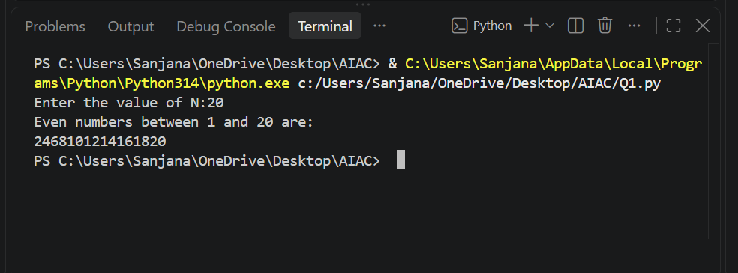

Task Description #2 (AI-Based Code Completion for Loop with Conditionals) Task:
Use an AI code completion tool to combine loops and conditionals
Expected Output:
● AI-generated code using loop and if condition.
● Correct count validation.
● Explanation of logic flow
Prompt:
Generate Python code to count how many numbers in a list are even and odd .
Code:
numbers = [1, 2, 3, 4, 5, 6, 7, 8, 9, 10]
even_count = 0
odd_count = 0
for num in numbers:
if num % 2 == 0:
even_count += 1
else:
odd_count += 1
print("Number of even numbers:", even_count)
print("Number of odd numbers:", odd_count)
Output:
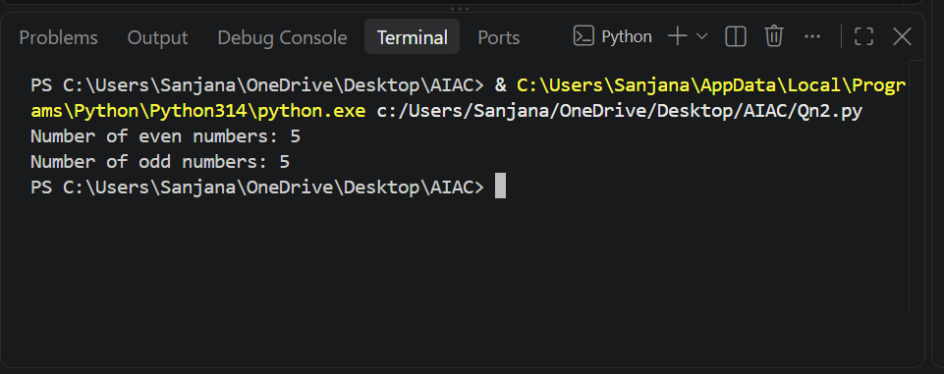

Task Description #3 (AI-Based Code Completion for Class Attributes Validation) Task:
Use an AI tool to complete a Python class that validates user input
Expected Output:
● AI-generated class with validation logic.
● Verification of condition handling.
● Test cases for valid and invalid inputs.
Prompt:
Generate a Python class User that validates age and email using conditional statements.
Code:
class User:
def __init__(self, name, age, email):
self.name = name
self.age = age
self.email = email

def validate_age(self):
if self.age < 18:
return "Age is below 18. User is not eligible."
elif self.age > 100:
return "Age is above 100. Please enter a valid age."
else:
return "Age is valid."

def validate_email(self):
if "@" not in self.email or "." not in self.email:
return "Invalid email format."
else:
return "Email is valid."

# Example usage
user1 = User("Alice", 25, "alice@example.com")
print(user1.validate_age())
print(user1.validate_email())
Output:
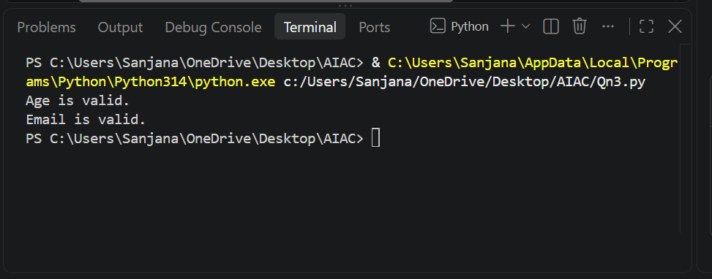

Task Description #4 (AI-Based Code Completion for Classes) Task:
Use an AI code completion tool to generate a Python class for managing student details.
Expected Output:
● AI-generated class code.
● Verification of correctness and completeness of class structure.
● Minor manual improvements (if needed) with justification
Prompt:
Generate a Python class Student with attributes (name, roll number, marks) and methods to calculate total and average marks.
Code:
class Student:
def __init__(self, name, roll_number, marks):
self.name = name
self.roll_number = roll_number
self.marks = marks # marks should be a list of integers

def calculate_total(self):
return sum(self.marks)

def calculate_average(self):
if len(self.marks) == 0:
return 0
return self.calculate_total() / len(self.marks)

# Example usage
student1 = Student("Sanjana", "A709",[88, 79, 90, 95])
print("Student Name:", student1.name)
print("Roll Number:", student1.roll_number)
print("Total Marks:", student1.calculate_total())
print("Average Marks:", student1.calculate_average())
Output:
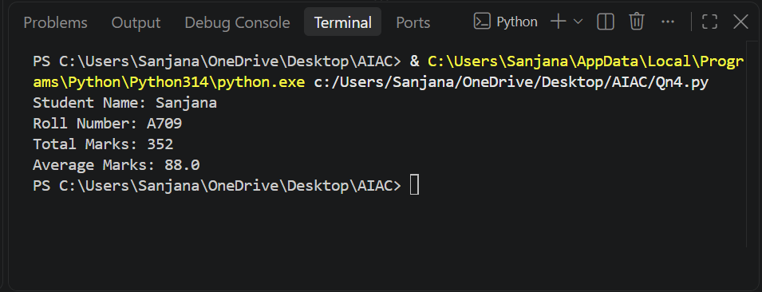

Task Description 5 (AI-Assisted Code Completion Review) Task:
Use an AI tool to generate a complete Python program using classes, loops, and conditionals together.
Expected Output:
● Complete AI-generated program.
● Identification of strengths and limitations of AI suggestions.
● Reflection on how AI assisted coding productivity.
Prompt:
Generate a Python program for a simple bank account system using class, loops, and conditional statements.
Code:
class BankAccount:
def __init__(self, account_number, account_holder, balance=0):
self.account_number = account_number
self.account_holder = account_holder
self.balance = balance

def deposit(self, amount):
if amount > 0:
self.balance += amount
print(f"Deposited: ${amount}. New balance: ${self.balance}.")
else:
print("Deposit amount must be positive.")

def withdraw(self, amount):
if amount > 0:
if amount <= self.balance:
self.balance -= amount
print(f"Withdrew: ${amount}. New balance: ${self.balance}.")
else:
print("Insufficient funds for this withdrawal.")
else:
print("Withdrawal amount must be positive.")

def display_balance(self):
print(f"Account Number: {self.account_number}, Account Holder: {self.account_holder}, Balance: ${self.balance}.")
account=BankAccount("987654321", "Sanjana", 1459)
while True:
print("\nBank Account Menu:")
print("1. Deposit")
print("2. Withdraw")
print("3. Display Balance")
print("4. Exit")
choice = input("Enter your choice (1-4): ")

if choice == '1':
amount = float(input("Enter amount to deposit: "))
account.deposit(amount)
elif choice == '2':
amount = float(input("Enter amount to withdraw: "))
account.withdraw(amount)
elif choice == '3':
account.display_balance()
elif choice == '4':
print("Exiting the program.")
break
else:
print("Invalid choice. Please try again.")
account.display_balance()
Output:
